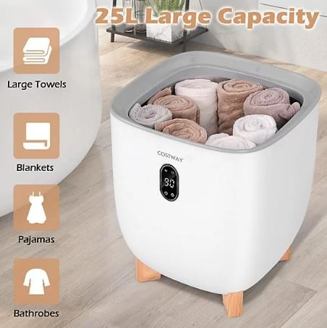
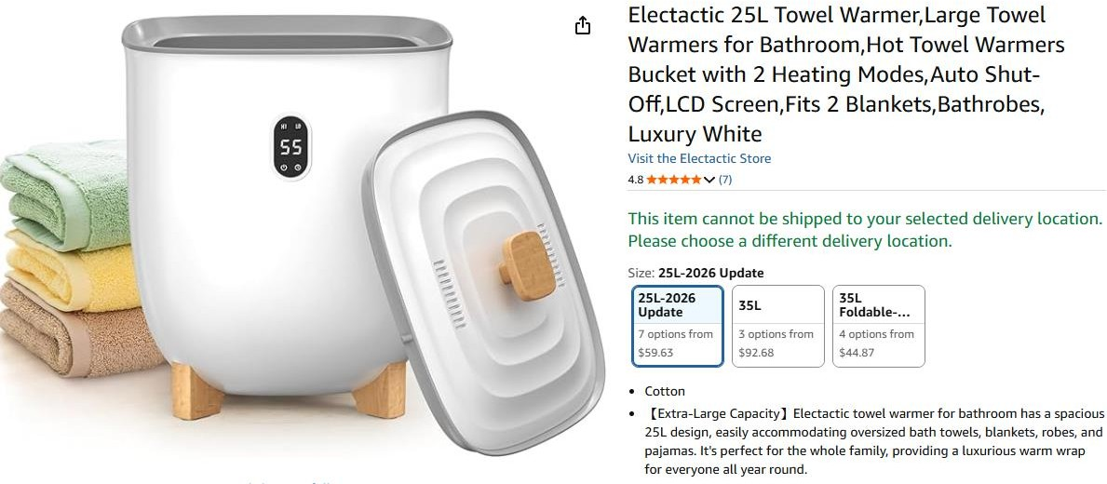
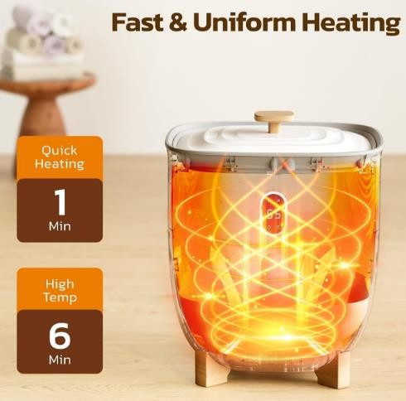

914pcs x ELECTACTIC 25L Towel Warmer Bucket Electric Hot Blanket Heater………Selling on amazon for $59.63

